**Volumetric 3 Tutorials: fMRI Data**

**(UPDATE)**

Several parts of these tutorials have been made easier in the current edition of volumetric. In addition a new feature called Ray Cast Rendering has been added, and can take the visuals to an even higher quality. However the shading feature for Ray Cast Rendering is very finicky, so it is left off by default. Importantly, the pre-processing steps have not changed.

**List of Tutorials**

* Pre-Processing
* Quick and Dirty Visualization
* Publication Quality Visualization
* Using Mask Layers

**Pre-Processing Stage**

**Notes:**

MRI data comes in a variety of configurations. This general process should work for most of them.

**Steps:**

1. Create 3 Folders
   1. \Originals
   2. \Co-Registered
   3. \Oriented
   4. \Visualization
2. Put all data files to be visualized in \Originals
   1. Required
      1. Anatomical Scan
      2. Mean Functional
   2. Optional
      1. Masks, F-Values, Etc.
3. Make sure all files in \Originals are .img files
   1. Convert any .mat files to their corresponding .img files and copy the .hdr files from the mean functional and rename them to match the newly created .mat files.
   2. WARNING: Make sure that the method used to convert the .mat files to .img files does not at any point flip the write order. If this happens you data will appear to be in the wrong part of the brain (This is not always obviously wrong)
4. Co-register the Mean Functional (and any additional files) to the Anatomical
   1. Load SPM
   2. Select Est & Re-slice
   3. Set the (Reference Image) to be the (Anatomical) (this is reversed from normal usage)
   4. Set the (Source Image) to be the (Mean Functional) (Again the reverse of normal usage)
   5. Set Additional Files to be any files you want to visualize
   6. Hit Play (optionally set the prefix to something like “co_”)
5. Cut and Paste all of the Co-Registered files to the \Co-Registered folder, also copy and paste the Anatomical scan to the Co-Registered folder.
6. Segment the Anatomical (Optional, but Recommended)
   1. Open SPM
   2. Click Segment
   3. Set (Data) to the Anatomical .img file
   4. Hit Play
   5. Include these files in any additional steps to use them for visualization. These are very important for making publication quality images.
7. Open Volumetric
   1. In the layer window click (Tools)
   2. In the drop down select (Rotate)
   3. A window should pop-up showing a set of axes and another window near it should ask for rotation parameters
   4. Click (Load Reference Volume) and select the Anatomical scan in \Co-Registered
   5. Click (Load Additional Volumes) and select any additional files you want to add. It only adds one at a time.
   6. In the axes window you should see a head lying on it’s side, Click –Y to rotate it towards upright. 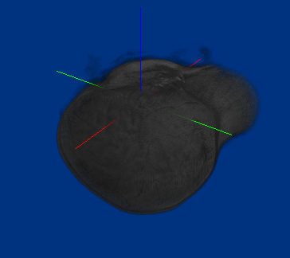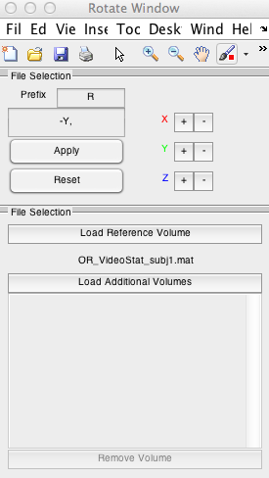
   7. Click Apply (This will create a new set of files with the R_ prefix, you can change this setting if you want, they will be saved to the same directory)
8. Put all newly created rotated files in \Oriented, and move to that directory
9. Interpolate (Optional)
   1. Load Volumetric if it is not open
   2. Click (Tools) -> (Scale). This window should pop up.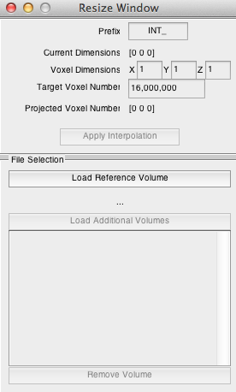
   3. Click (Load Reference Volume) and Set it to any of the files in \Oriented
   4. Click (Load Additional Volumes) and select all of the other files in \Oriented
   5. Change (Target Vox Num) to 20000000 or 20 million. This is a pretty good resolution for visualization purposes. 27M will be pretty high quality, but will slow down many machines.
   6. Hit Apply Interpolation. The files will be saved to same directory with a prefix of your choosing.
10. You have completed the pre-processing stage

Quick Terminology

1. Alpha refers to the transparency of rendered object. You will often see RGB-A, which means a color with an alpha term. The letter “A” will be used in Volumetric to denote things that manipulate Alpha or Transparency Properties in addition to this Icon Macintosh HD:Users:james:Desktop:Volumetric Development:Application 3 Development:Volumetric 3:AlphaIcon20.jpg, mainly the alpha target selector. The color selector will be denoted with this 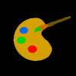.
2. A Color Map refers to a mapping of data values (e.g 1 2 4 .5) to colors in a smooth way. This is an example of a color map.Macintosh HD:Users:james:Desktop:Volumetric Development:Application 3 Development:Tutorial:Screen Shot 2014-11-12 at 8.02.32 PM.png The values farthest to the left represent low data values like 0. The values farthest to the right represent the highest values in a dataset.
3. An Alpha-Map refers to a mapping of data values to transparencies. This is an example of a color map in Volumetric. Macintosh HD:Users:james:Desktop:Volumetric Development:Application 3 Development:Tutorial:Screen Shot 2014-11-12 at 8.05.22 PM.png Again left refers to low values and right refers to high values. Lighter values here are more opaque whereas darker values are more transparent. Because of the way volumetric visualizations work, even very dark values are still visible in the renderings.

**Visualization Stage (Quick & Dirty)**

**Note:**

This visualization is Good for checking that things are in order, while it is probably not good for presentation and publication.

**Steps:**

1. Type Volumetric in Matlab to open Volumetric if it is not already open.
2. Go to the (Edit Window) and click (Load Color Source), use the file menu to select the Anatomical file in \Oriented
3. Go to the (Edit Window) and click (Load Alpha Source), use the file menu to select the Anatomical file in \Oriented
   1. In the Import Option window set (Min) to 1000 (make sure to delete the minus sign). Functional scans a have a big range of values and after Co-Registration they may have negative values (just a noise artifact). A high Minimum like 1000 will tend to exclude most hemodynamic response outside the brain.
4. Go to the (Layers Window) and Right Click (Ctrl Click on the MAC) on (Base Layer) then Click (Add New Layer). This will add a new layer and open it up in the Edit Tab.
5. Rename the New Layer to Mask
6. (Load Color Source) and set it to the mask in \Oriented, in (Import Options) turn on (Smoothing). This takes a binary mask and smooth’s it so that zero values transition smoothly into 1’s (Highly recommended). Apply.
7. In the Rendering a blue and red brain should now be displayed with purple and Green blobs inside it. These blobs are your masks.
8. Click (Base Layer) to return to editing the base layer.
9. Click the (Alpha) Macintosh HD:Users:james:Desktop:Volumetric Development:Application 3 Development:Volumetric 3:AlphaIcon20.jpg button to toggle the transparency editor to black.
10. Now Click on the lower map the Alphamap and make it look like this
    1. Macintosh HD:Users:james:Desktop:Volumetric Development:Application 3 Development:Tutorial:Screen Shot 2014-11-12 at 8.27.23 PM.png
11. Make sure the dark areas are almost completely black and you should get something that looks a little like this. 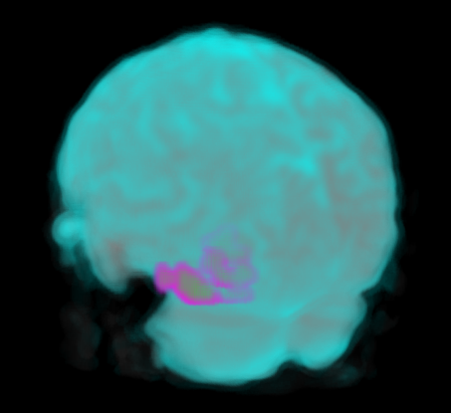
12. While this may look cool it is not the best thing for finding anatomical landmarks. But it should show you very quickly whether or not your masks are in the right place.

Quick Terminology

1. Shading refers to the appearance of three-dimensional form due to lighting across and object.
2. There is no lighting in Volumetric so we need to trick the eye if we want the appearance of hard surfaces with strong shading.
3. This is relatively easy to do in Volumetric

**Visualization – Shell + White Matter**

**Note:**

This is a pretty useful and flexible visualization. Using high-resolution sources it is suitable for publication and presentation.

**Steps:**

1. This visualization requires segmented the Anatomical during pre-processing. If you did not do this go back and do it.
2. Additionally this visualization will look much better when using the rescaled versions of the data so use the 20M voxel batches if you made them.
3. Open Volumetric
4. Base Layer
   1. (Load Color Source) – \Oriented\c1Anatomical (this is the cortex)
      1. Set Min to 40 Max to 200
      2. Turn (Smoothing) on
      3. Turn (Values Above Max to 0) on
   2. Do the same for (Load Alpha Source)
   3. Make the Colormap and the Alpha map look like this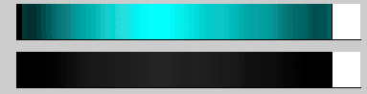Notice that the alpha map has a very faint smudge in the middle that extends outwards. **(UPDATE)** It is now easier to see faint transparency values in the actual program. In addition both of these maps are now included in the preset menu.
5. (Add New Layer) Call it “White Matter”
   1. (Load Color Source) – \Oriented\c2Anatomical (this is the cortex)
      1. Set Min to 40
      2. Turn (Smoothing) on
   2. Do the Same for (Load Alpha Source)
   3. Edit Color Map and Alpha Map to look like this 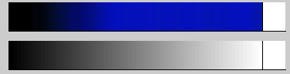 The color map is all that needs to change from default.
6. (Add new Layer) Call it “Mask or Values”
   1. (Load Color Source) – \Oriented\c2Anatomical (this is the cortex)
      1. Turn (Smoothing) on
   2. Color Map and Alpha Map should look like this 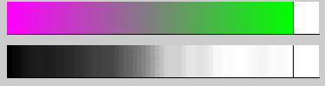
   3. You can change the colors here if you want. Masks tend to be very noisy, because of this and the smoothing applied earlier green will tend to indicate contiguous regions of voxels while purple will indicate edge or diffuse voxels.
7. The end result will look something like this 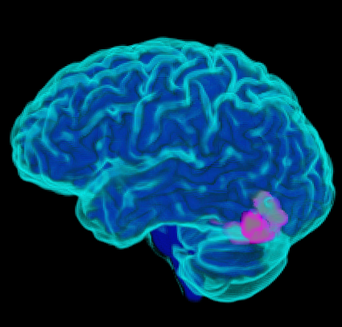
8. If you want to emphasize the white matter try adding the White Matter and grey matter to a Blend Group. Right Click (Ctrl click on MAC) -> (Add to Blend Group) then click on Base Layer.
9. The result should look a little like this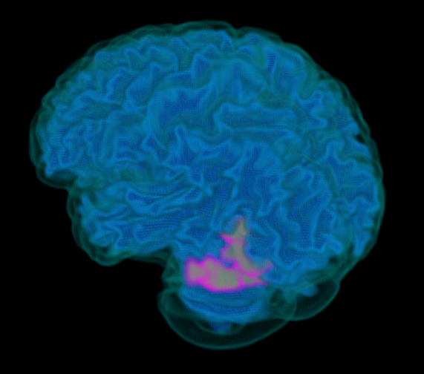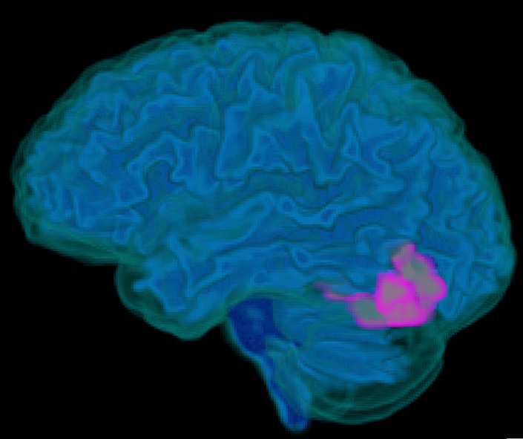
10. When you are ready to save your visualization Click (Save) in the (Layers Window) and save to the \Visualization directory for convenience. Now you can load this visualization any time by Clicking (Load)
11. You can create special spatial masks with (Tools) - > Make XYZ volumes
12. These allow you to use these XYZ layers to selectively mask regions of preceding layers. Like so 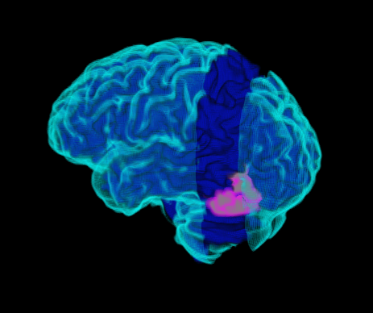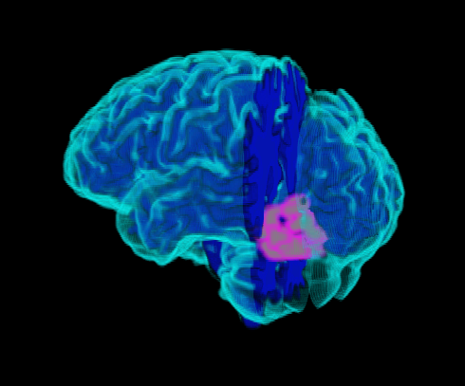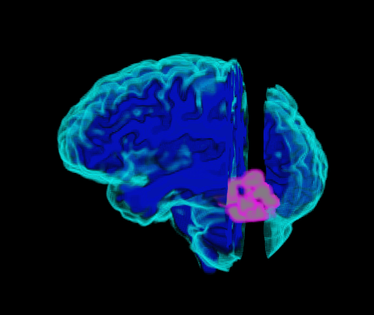

**Quick Terminology**

1. Layer Oder refers determines how the layers are rendered.
2. When the Alpha Source of a layer has 0 values, the layers below it can show through where the values are 0. Setting values to zero is typically handled in the (Import Options Window), while loading the Source files.
3. Everywhere the Alpha Source has non-zero values, only that layer or above will show, even if the the alpha map is set to be completely transparent for all values.
4. While this may seem mildly limiting it can be overcome by using blend-groups, we will talk about those later.
5. In the meantime, this feature allows us to create layers specifically designed to mask lower layers, or to cut-away sections of our brain visualization while leaving others intact.

**Using Mask Layers**

**(Outdated) – This process has been simplified and no longer requires an in depth tutorial.**

You can still use the following method to create mask layers, but now there is a gui option that automates most of this process. You can find it under (Tools)->(Add New Mask Layer). It will always set the new mask layer to be the first layer, but you can move it around just like a normal layer. This vastly simplifies cutting into and splitting your visualizations using rectilinear masks.

1. Have the previous visualization open.
2. Make a set of XYZ masks
   1. Click (Tools) -> (Make XYZ Vols)
      1. Save them as Spatial Mask
      2. This produces (X_Spatial Mask, Y_Spatial Mask, Z_Spatial Mask)
   2. (Add New Layer ) called X-Mask
      1. If using the 20M resolution data
      2. (Set Color Source) to X_Spatial Mask
      3. (Set Alpha Source) to X_Spatial Mask
         1. Min to 200, Max to 230
         2. (Smoothing) ON
         3. (Values Above Max to 0) ON
   3. Move (X-Mask) to be above (Base Layer)
      1. Right Click(or Ctrl click on MAC) on X-Mask in the (Layers Window) and then select (Move) then click on Base Layer.
3. Result should look like this 
4. Move The X-Mask above White Matter for this 
5. You can add more Mask layers to mask rectangular regions as u see fit.

Final Note

If you want to make some of the more advanced and eye-catching images, I highly recommend looking at the test files folder included with volumetric. Because the layer structure is saved you can look at how the alpha and color maps were designed for each example.